Session Token

🔐 What Is a Session Token?
# Source: Chatgpt (GPT-5-Mini) at [1/20/2026]
A Session Token is a unique identifier issued by a server to a client after a successful login. It is used to maintain the user's authenticated session between requests.

✅ Simple Definition:
# Source: Chatgpt (GPT-5-Mini) at [1/20/2026]
A Session Token lets the server recognize who you are after you log in — so you don’t have to re-enter your username and password on every request.

🧠 Real-Life Analogy:
# Source: Chatgpt (GPT-5-Mini) at [1/20/2026]
Think of visiting a theme park:
- You enter once and get a wristband (session token)
- It shows you’re allowed inside for the whole day
- You can now go on any ride without re-showing your ID
Same with a session token — it's your proof of login for a short period.

🔄 How Session Tokens Work
# Source: Chatgpt (GPT-5-Mini) at [1/20/2026]
- You log in with username/password
- Server verifies your identity
- Server creates a unique session token
- The token is sent to your browser or client app
- You send it with each request — so the server knows it's still you

🔐 Where It's Stored?
# Source: Chatgpt (GPT-5-Mini) at [1/20/2026]
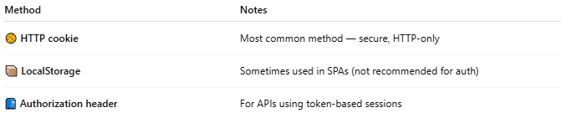

Method | Notes
🍪 HTTP cookie | Most common method — secure, HTTP-only
📦 LocalStorage | Sometimes used in SPAs (not recommended for auth)
📮 Authorization header | For APIs using token-based sessions

📦 Example Session Token
# Source: Chatgpt (GPT-5-Mini) at [1/20/2026]
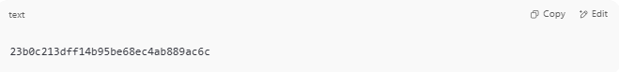
23b0c213dff14b95be68ec4ab889ac6c

- Random, unique, not readable (unlike JWTs)
- Stored server-side with session data (e.g., user ID, expiry)

🧠 Stateless vs Stateful Sessions
# Source: Chatgpt (GPT-5-Mini) at [1/20/2026]
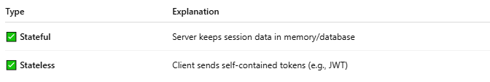

Type | Explanation
✅ Stateful | Server keeps session data in memory/database
✅ Stateless | Client sends self-contained tokens (e.g., JWT)

⚠️ Security Best Practices
# Source: Chatgpt (GPT-5-Mini) at [1/20/2026]
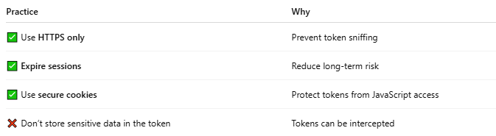

Practice | Why
✅ Use HTTPS only | Prevent token sniffing
✅ Expire sessions | Reduce long-term risk
✅ Use secure cookies | Protect tokens from JavaScript access
❌ Don’t store sensitive data in the token | Tokens can be intercepted

🔁 Session Token vs Other Tokens
# Source: Chatgpt (GPT-5-Mini) at [1/20/2026]
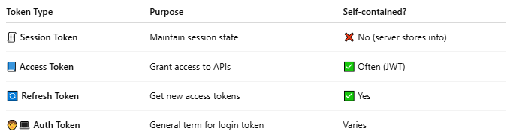

Token Type | Purpose | Self-contained?
🧾 Session Token | Maintain session state | ❌ No (server stores info)
📘 Access Token | Grant access to APIs | ✅ Often (JWT)
🔄 Refresh Token | Get new access tokens | ✅ Yes
🧑‍💻 Auth Token | General term for login token | Varies

📌 Summary
# Source: Chatgpt (GPT-5-Mini) at [1/20/2026]
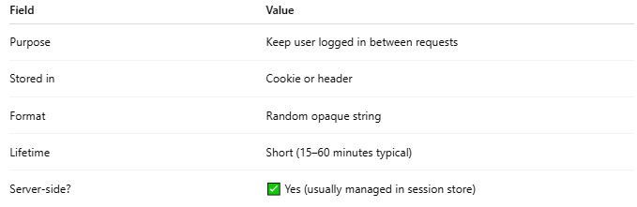

Field | Value
Purpose | Keep user logged in between requests
Stored in | Cookie or header
Format | Random opaque string
Lifetime | Short (15–60 minutes typical)
Server-side? | ✅ Yes (usually managed in session store)

